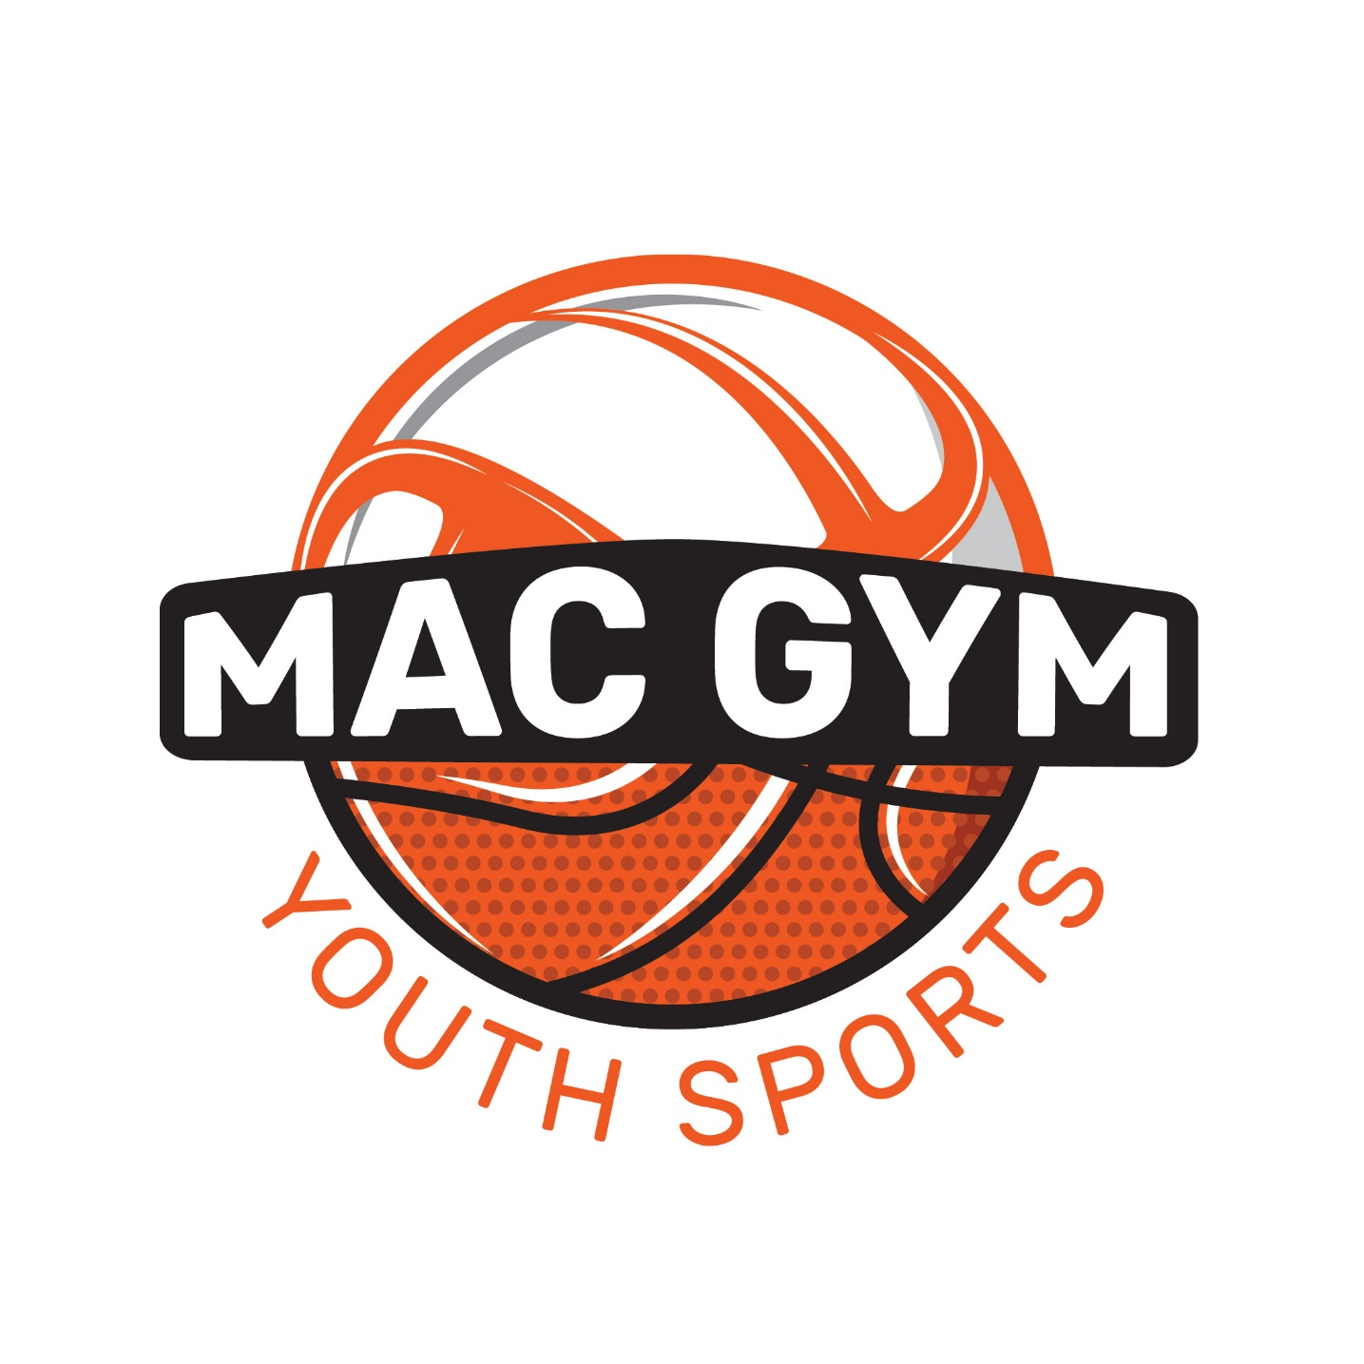
MAC GYM SPONSOR FORM
The MAC Gymnasium is accepting sponsorship applications for the purpose of advertisement to hang in the gym to help keep cost for athletes low. Banners will be hung in the gym for one year from the date of purchase. There are two options for signage:
- $250 donation for an approximate 48” X 36” (actual size depends on information requested on banner) banner. The Mac Gym buys the banner the first year out of your donation. Each proceeding year the same banner will remain with the $250 donation. Information for the banner can be provided by a business card, computer .dxf file (preferred), or manually written.
- $400 donation for an approximate 96” X 48” (actual size depends on information requested on banner) banner. The Mac Gym buys the banner the first year out of your donation. Each proceeding year the same banner will remain with the $400 donation. Information for the banner can be provided by a business card, computer .dxf file (preferred), or manually written.
- Additionally, The Mac Gym will be putting together roster brochures this year for our Volleyball and Basketball leagues. (These will be like the brochures the Athletic Boosters put out at high schools) Information for the brochure can be provided by a business card, or (Preferred) JPEG or PDF 300 DPI or higher. If you are interested in advertising in these brochures, we have three options available:
  - $50 Business card Full color
  - $125 ½ page Full color
  - $225 Full page Full color

Thank You for your consideration

Blake Whitman
Owner

SPONSORSHIP INFORMATION

Business Name:___________________________________________

CONTACT INFORMATION
Name:_________________________________________________
PHONE:________________________________________________
EMAIL:________________________________________________

- $250 Small Gym Banner
- $400 Large Gym Banner
- $50 Business Card Full Color Brochure
- $125 ½ Page Full Color Brochure
- $225 Full Page Full Color Brochure

Make Checks Payable To: MAC GYM
For any questions please contact:
Blake Whitman
7943 Cicero Rd Cell: 419-487-1555
Hicksville, Oh 43526 Email: macgymohio@gmail.com

